**COUGAR CONNECT**

A KEAN UNIVERSITY ONLINE FORUM

**USER MANUAL**

Version 1.0

11/1/2022

**TABLE OF CONTENTS**

**1. LANDING PAGE** [**3**](https://docs.google.com/document/d/1nd07OZ9jIqE1yUVkAIpZxTrE9sEP61RvjWlhOABN7HY/edit#heading=h.esldm3eyefun)

1.1. SIGN UP FORM 3

1.2. LOGIN FORM 4

**2. HOMEPAGE** [**4**](https://docs.google.com/document/d/1nd07OZ9jIqE1yUVkAIpZxTrE9sEP61RvjWlhOABN7HY/edit#heading=h.9yye3fnh18d4)

2.1. NAVIGATION BAR 4

2.2. SIDE MENU 5

2.3. POSTS DISPLAY 6

**3. PROFILE 6**

3.1. PROFILE BANNER 6

3.2. DISPLAY SELECTION [7](https://docs.google.com/document/d/1nd07OZ9jIqE1yUVkAIpZxTrE9sEP61RvjWlhOABN7HY/edit#heading=h.7fniy1zf7t3x)

**4. SETTINGS 8**

4.1. ACCOUNT 8

4.2. NOTIFICATIONS 8

4.3. PRIVACY 9

4.3. THEME 9

**5. DISCUSSIONS** [**9**](https://docs.google.com/document/d/1nd07OZ9jIqE1yUVkAIpZxTrE9sEP61RvjWlhOABN7HY/edit#heading=h.6733n7hd1t1e)

5.1. SORT ORDER 9

5.2. FILTER 10

5.3. MARK AS READ 10

5.4. VIEW 10

5.5. INTERACT 11

5.6. CREATE 12

5.7. FOLLOW 13

5.8. FLAG 13

5.9. IGNORE/HIDE 13

**6. BLOGS** [**1**](https://docs.google.com/document/d/1nd07OZ9jIqE1yUVkAIpZxTrE9sEP61RvjWlhOABN7HY/edit#heading=h.91wzl35o30gr)**4**

6.1. CREATE 14

6.2. INTERACT 15

**7. TAGS** [**1**](https://docs.google.com/document/d/1nd07OZ9jIqE1yUVkAIpZxTrE9sEP61RvjWlhOABN7HY/edit#heading=h.ocxccga6zrfd)**5**

7.1. TAG TILES 15

# LANDING PAGE

When you first enter the website, you will be presented with the website’s landing page. Most options can be selected, but will display nothing in response. The only functional components here are in the navigation bar at the top of the page.

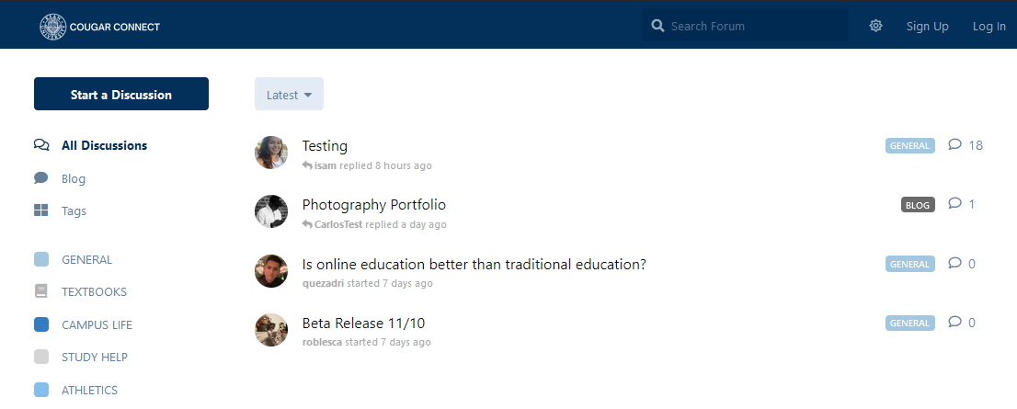

* **Home Button**

The home button is in the top left with the Kean Logo and COUGAR CONNECT label and will refresh your page when clicked.

* **Theme Toggle**

You can switch between light/dark mode using this button.

If you are in light mode, the button will be in the shape of a sun.

If you are in night mode, the button will be in the shape of a crescent moon.

* **Sign Up**

This option will display a popup sign up form for you to create an account.

* **Log In**

This option will display a popup login form for you to login to account.

## SIGN UP FORM

You will be prompted to sign up when you click the Sign Up option in the top right corner of the navigation bar. Here, you will be able to create your account with your already existing Kean email address.

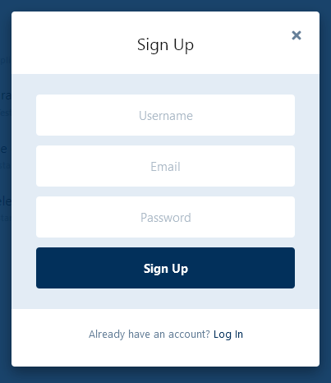

* **Username**

Fill in your desired username in the text box.

* **Email**

Fill in your Kean email address in the text box.

* **Password**

Fill in your desired password in the text box.

* **Sign Up**

Once all fields are filled, you can submit by clicking the Sign Up button.

* **Log In Option**

If you already have an existing account, you can click this which will redirect you to the login form.

## LOG IN FORM

You will be prompted to login when you click the LogIn option in the top right corner of the navigation bar. Here, you will be able to access the website with your already existing profile.

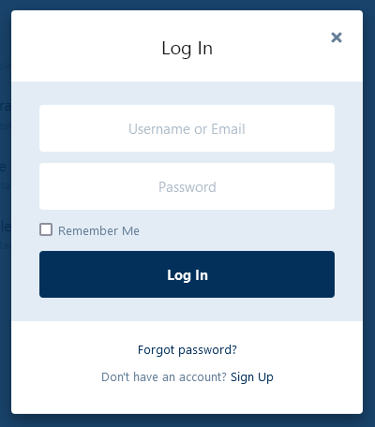

* **Username/Email**

Fill in the username/email address associated with your account.

* **Password**

Fill in the password associated with your account.

* **Remember Option**

Select this option if you want your login information to be saved, this will skip over the login form the next time you login.

* **Login**

Once all fields are filled, you can submit by clicking the “Log In” button.

* **Forgot Password Option**

In the case where you forget your password, you can select “Forgot password?”.

* **Forgot Password Form**

If you selected the “Forgot password?” option, you will be presented with a form where you can enter your email address and submit with the “Recover Password” button. An email will be sent to your email address with a link to reset your password.

* **Sign Up Option**

If you do not have an existing account, you can click this which will redirect you to the sign up form.

# HOMEPAGE

Once you have logged in, you will be presented with the homepage of the Cougar Connect website. Here you will have access to the full features of the platform. You will be able to create your own posts, see others’ posts and interact with them. You will also be able to edit your profile and modify the settings to personalize your experience.

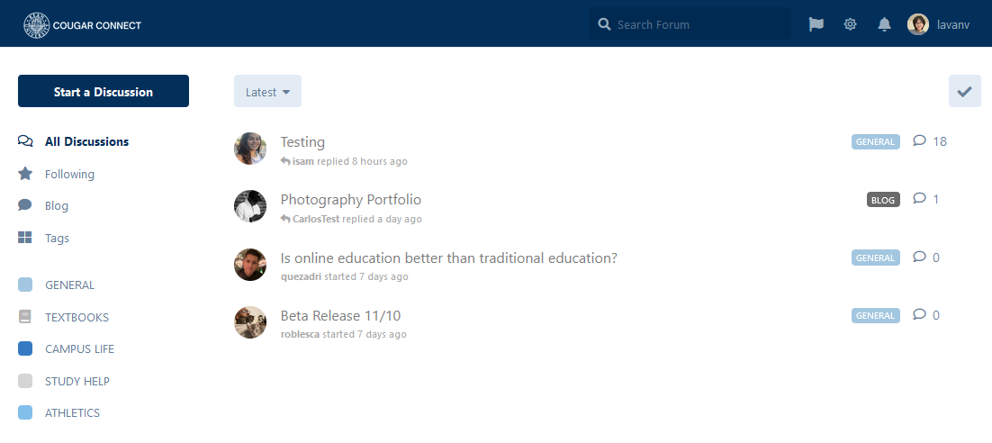

## NAVIGATION BAR

The navigation bar is the blue header at the top of the page. It contains a number of functions unrelated to creating and viewing posts.

* **Home Button**

The home button is in the top left with the Kean Logo and COUGAR CONNECT label and will refresh your page when clicked.

* **Search Bar**

The search bar is the box and magnifying glass. Here, you can enter text in order to search for either posts or users.

* **Theme Toggle**

You can switch between light/dark mode using this button.

If you are in light mode, the button will be in the shape of a sun.

If you are in night mode, the button will be in the shape of a crescent moon.

* **Notifications**

The notifications button is in the shape of a bell.

When clicking it, you will open up the notifications popup menu. Here, you can see all the notifications intended for you. You will also be able to mark them as read or delete them.

* **Profile**

The profile button is the circle with your profile picture and your username next to it.

When clicking it, you will be presented with the profile popup menu.

* **Profile Popup Menu**

The profile option will redirect you to your profile page.

The settings option will redirect you to your settings page.

The theme toggle can also be found here to allow you to switch between themes.

The logout option will allow you to log yourself out from the website. After you click it, you will be redirected to the blank landing page.

## SIDE MENU

The side menu is at the left side of the page below the header. Here, you can start your own discussion post and select options to manipulate the main display for posts.

* **Start a Discussion**

This button will bring up a popup prompt for you to create your own discussion post.

* **All Discussions**

This option will display all types of posts in the posts display.

* **Following**

This option will display only posts you follow in the posts display.

* **Blog**

This option will redirect you to a page which displays only blog-type posts.

* **Tags**

This option will redirect you to a page which displays all available post tags.

* **Tag Filters**

These options will display only posts based on the tag you selected.

## POSTS DISPLAY

The posts area displays all posts that have been posted to the website. Here, you can view all those posts as well as manipulate how you would want to view them.

* **Sort**

The sort button is a box in the top left with the current sorting option labeled inside it.

The default option is Latest.

This allows you to sort posts by latest, top, newest, and oldest.

* **Mark as Read**

The sort button is a box in the top right with a check mark inside.

This button will bring up a popup box for you to confirm whether or not you want to mark all posts as read.

* **Posts Selection**

Here, all posts are shown for you to view as well as select one of them to view further.

On the left is the profile picture of its creator.

Next to the profile picture is the title of the post and the most recent engagement on the post.

On the right is the name of the tag associated with the post and the amount of replies to the post.

Hovering over each post will show three dots to the right, this will allow you to select whether or not you want to follow the post.

# PROFILE

Your browser window’s top right corner contains a user profile. In your user profile, you will be able to make edits, update or add anything you’d like to your profile.

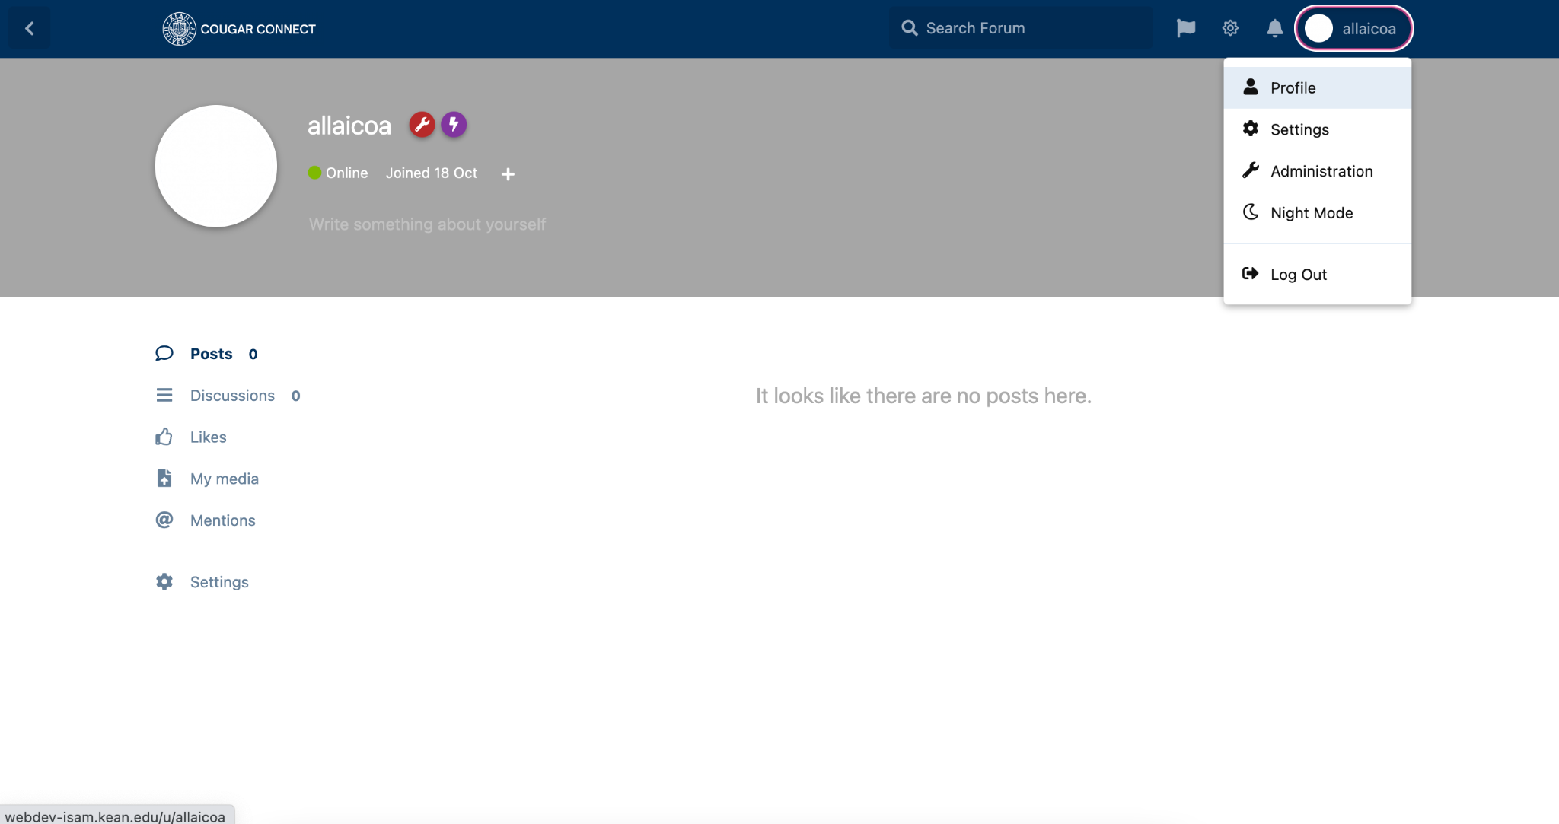

## PROFILE BANNER

When you go into your user profile page, your profile banner will consist of elements to adjust your bio at your preferences.

* **Controls**

This drop-down button will allow you to edit your username, add/remove cover photo, or delete your profile.

* **Profile Picture**

If you are a first time user, you can add a profile picture by hovering over the profile circle icon and click on it. Once clicked, it will prompt you to your desktop documents where you will select a png, jpg, or jpeg image to add as your profile photo.   
If you already have a profile picture, you are prompted with an “upload” or “remove” option where you can either upload a new profile picture or remove the current profile picture.

* **Cover Photo**

To upload a cover photo, on the top right of your browser, click on the “Controls” drop down and select “Cover.” A small window will open with options to either ''upload” or ''remove” your cover photo.

* **Bio**

To add/edit your bio, you can simply click on the textbox under your status and begin typing your bio. Your savings will save automatically.

* **Username**

To change your username, click on the “Controls” drop down button and click on “Edit.” A dialogue window will open where you can change your username and click “Save Changes’ button to complete your changes.

* **Status**

This allows users to view if you are online or offline. If you are online, it will show a green circle. If you are offline, a gray circle will appear.

## DISPLAY SELECTION

Once logged in, you have various options to view any activity that you are involved in with your user account.

* **Posts**

Allows you to view any posts you created.

* **Discussions**  
  Allows you to view any discussions you created.
* **Likes**  
  Allows you to view any posts/discussions you like.
* **My media**  
  Allows you to view any idea you uploaded.
* **Mentions**  
  Allows you to view any mentions you have been tagged in
* **Settings**

Allows you to make changes to your account.

# SETTINGS

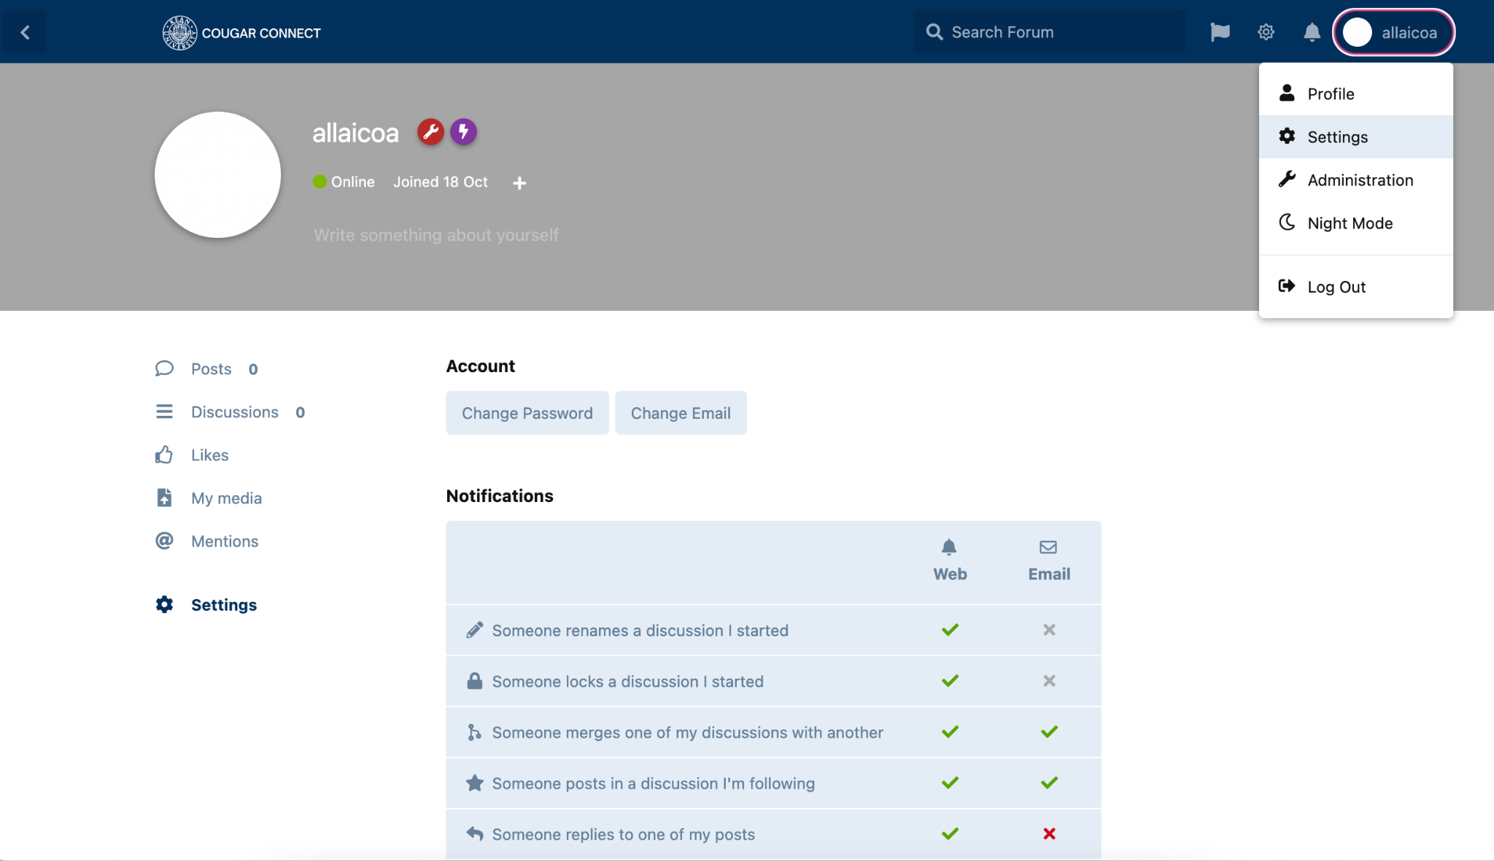

## ACCOUNT

You can adjust your account settings such as password and email.

* **Change Password**  
  Allows you to change your password. When you click on it, it will prompt a dialogue window with a “Send Password Reset Email” button. Then, you need to navigate to your email to the reset email to change your password.
* **Change Email**  
  Allows you to change your email. When you click on the button, a small dialogue window will open showing your current email. You can change the email and enter your password and click on “Save Changes” to successfully change your email.

## NOTIFICATIONS

You can modify your notifications to receive it on the website, email, or both.

* **Rename**

Enable to receive notification if someone renames a discussion you started.

* **Lock**  
  If someone locks a discussion you started.
* **Merge**  
  If someone merges your discussion with another.
* **Followed Discussion**  
  If someone posts in a discussion you are following.
* **Replies**  
  If someone replied to one of your posts.
* **Mentions**  
  If someone mentions you in a post.
* **Likes**  
  If someone likes your posts.
* **Follow When Reply**  
  Automatically follow discussions that you reply to.
* **Notify New Posts**  
  Notify about every new post, instead of only the last in a discussion.

## PRIVACY

Enable/Disable your privacy

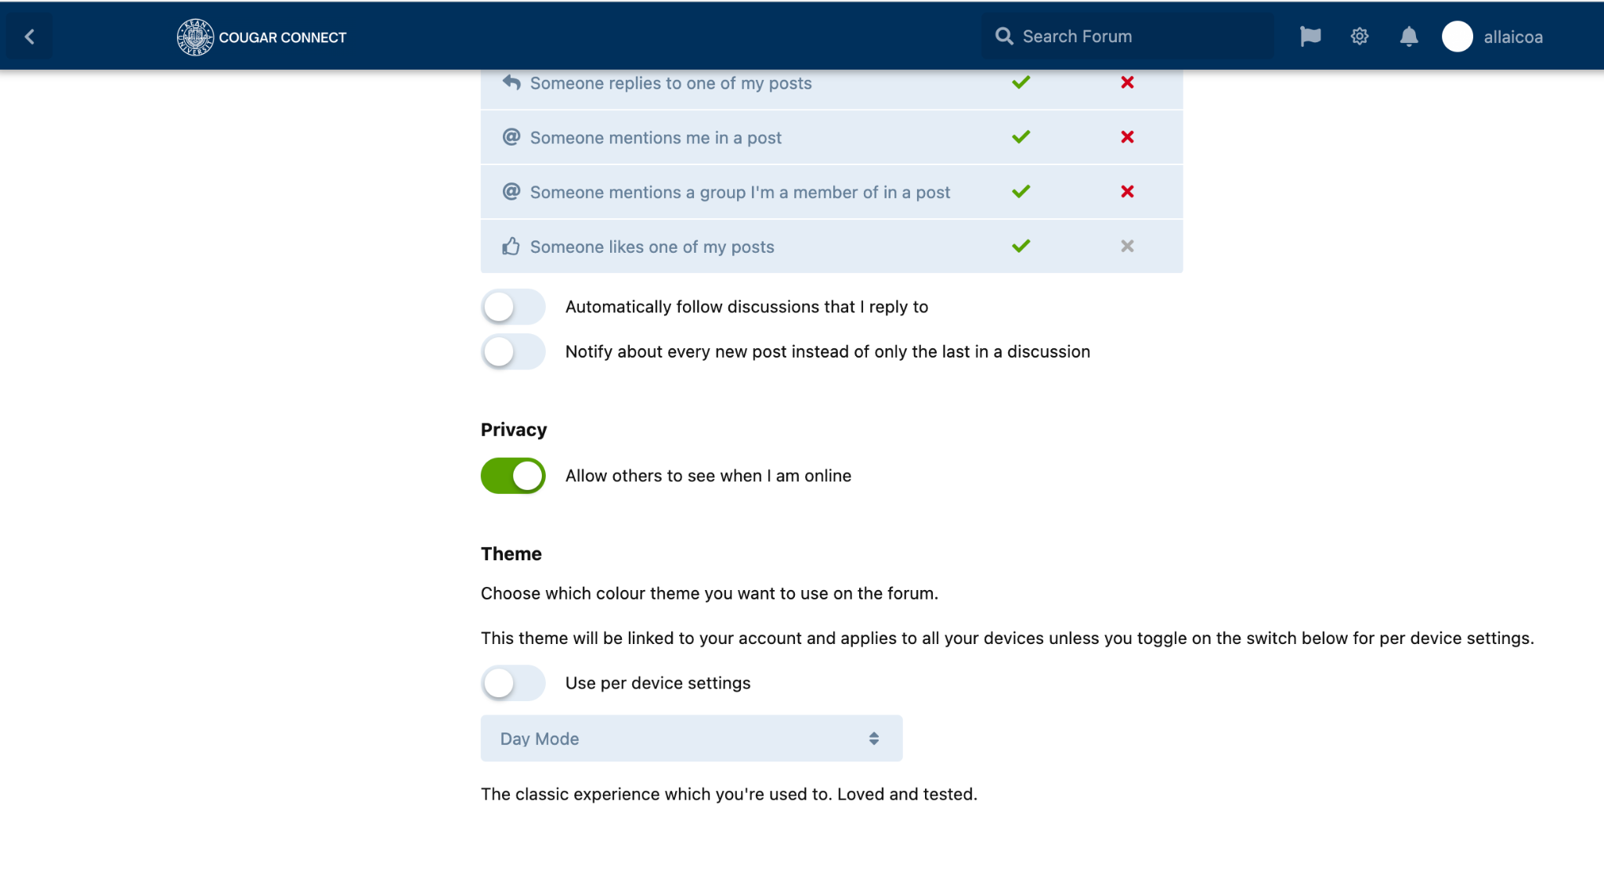

* **Status View**Allows you to choose whether you want a user to see your status offline/online.

## THEME

Choose which color theme you want to use on the forum. It will be linked to your account and applied to all of your devices unless you toggle on the following buttons.



* **Use per device settings**  
  Enable to apply the theme to every device on your account.
* **Theme Selection**

Drop down button to select day/night mode or automatic (browser’s original mode)

# 

# DISCUSSIONS

On the homepage, clicking "All Discussions" will provide you with a view of all discussions created within the forum regardless of tag/blog category.

## SORT ORDER

If you want to sort the order discussions, you can sort it to one of the following options. (Note: The sort order of discussions is automatically set to “Latest”).

* **Latest**

Select to sort order of discussions from the most recently replied to discussion to the oldest replied to discussion.

* **Top**

Select to sort order of discussions from the most interacted with discussion to the least interacted with discussion.

* **Newest**

Select to sort order of discussions from the most recently created discussion to the oldest created discussion.

* **Oldest**

Select to sort order of discussions from the oldest created discussion to the most recently created discussion.

## FILTER

* **Select Category**

The side menu on the left hand side of the discussions gives you the option to filter the discussions by tag or by who you are following. (*See Section 2.2 SIDE MENU, for further details about these categories.)*

## MARK AS READ

Titles of all unread discussions as well as discussions that receive new replies since your last visit to that specific discussion will appear in **bold** lettering.

* **Mark All As Read**

To mark all discussions as read, in the top right hand corner above the top discussion on your list there is a check mark button. Click the checkmark and all discussions will be marked as read until a new discussion/reply is created.

## VIEW

Hover over any discussion you’d like to view on the list, click it to open up the discussion and view its content and all replies.

* **Browsing**

To browse the discussion you can scroll up and down through the replies.

* **Slider**

Another option is to use the slider on the right hand side of the page, you can click and drag the slider vertically, or alternatively you can continuously click on the slider and it will go through each post one by one. The slider indicates which number the current post you are viewing is in the discussion. (For example it may say 3 of 5 posts) It will also include the month and year that post was created.

* **Original Post**

Above the slider you will see an “Original Post” option, when clicked it will automatically jump you to the first post that initially created the discussion.

* **Now**

Below the slider you will see a “Now” option, when clicked it will automatically jump you to the most recent post under the discussion.

## INTERACT

* **Like**

To like a post, hover over the post and click the “Like” button.

* **Reply**

There are 3 different ways to begin a reply to a discussion

1. Hover over a post, and click “Reply”.
2. On the top right hand side of the discussion, click the “Reply” button.
3. Scroll to the bottom of a discussion and click on the placeholder that says “Write a Reply…”.

Lastly, when finished, click the “Post Reply” button at the bottom left of the page.

* **Modify Text**



After creating a reply or starting a new discussion, at the bottom you have different options to stylize your text. You can add headers, make text bold, italicize text, strikethrough text. You can also insert a link, quote, spoiler, and also add code.

* **Media**



You can upload a picture to post by clicking the right “Upload” button pictured above. It will bring up a file manager allowing you to select a photo from your device. Files you upload will be saved and can be accessed on any reply or discussion creation post by clicking on the left “Media Manager” button pictured above.

* **Mention**



You can mention other users in a post by simply typing @ followed by the username of the user you’d like to mention. Alternatively, you can click on the “@” button pictured above.

* **GIFs and Emojis**



Add GIFs, by clicking on the “GIF” button pictured above.



Add emojis by using your keyboard if you’re on an iOS or Android device, or alternatively you can add emojis by clicking on the smiley face button pictured above.

* **Preview Reply**



If you’d like to preview how your reply would look in the discussion before posting, click the eye button pictured above.

## CREATE

To begin creating a discussion click “Start a Discussion” on the left hand side of the page, from there you must do the following…

* **Title**

Click on the placeholder that says “Discussion Title”, then enter the title of the post that you are creating.

* **Content**

Click on the placeholder that says “Write a Post…”, then enter the content that you are creating a discussion about. (*See further down Section 5.6 INTERACT WITH A DISCUSSION to see more details about the type of things you can include in your post such as pictures, links, etc.)*

* **Tags**

Click on the button that says “Choose Tags”, from there you will see a pop up box with all the tags currently available to choose from. Select up to as many tags as you’d like, as well as subcategories of that tag, if applicable.

* **Submit**

Once you’ve completed the steps above, click “Post Discussion” and you’re done. (Note: If you forget to add a Tag before clicking “Post Discussion” you will be prompted to do so as you cannot post without including a Tag. Also, if you forget to include a Title, you will receive an error message stating that the title field is required.)

## FOLLOW

You can follow a discussion, once followed it will appear on the list when you select the filter “Following”.

* **From Discussions List**

To follow a discussion from the discussion list, hover over the discussion you would like to follow, once hovering you will see three vertical dots appear, click the three vertical dots, then click “Follow”.

* **From Inside Discussion**

Once in a discussion, click the “Follow” button on the right hand side.

## FLAG

You can flag a post that may be inappropriate or not in accordance with the site’s Code of Conduct to be reviewed by one of the site’s administrators.

* **From Inside Discussion**

Hover over the post you would like to flag, click the three dots that appear in the bottom right corner of the post, then click on “Flag”. Next, a prompt will appear asking you to select a reason for flagging the post. These options are, “Off-topic”, “Inappropriate”, “Spam”, or “Other”. (Note: If you select “Other”, a text box will appear and you must specify the reason for flagging the post.) Lastly, click on “Flag Post”.

## IGNORE/HIDE

You have the option to hide a discussion from the discussions list or ignore all notifications related to a discussion.

* **From Discussions List**

Click the discussion you choose to hide. Next, click the drop-down arrow next to the “Follow” button and then click “Ignoring”. (Note: This option only hides the discussion from the main discussions list, when filtered by tags/blog the discussion will once again be visible.)

* **Unhide**

Hover over the discussion you choose to unhide. Three vertical dots will appear on the right side of the discussion, click the three vertical dots and then and click “Unignore”.

# BLOGS

You can create a personal blog that will be posted just like a discussion with slight differences.

## CREATE

Once on the blog category homepage, click on the “Write Article” button on the right hand side of the page. On the next page you’ll be able to

* **Select a Category**

Click on “Select A Category”, just as with discussion tags a pop up will appear and you will be prompted to select tags that relate to your post.

* **Title**

Click on “NO TITLE”, a pop up will appear and you will be prompted to enter a title for your blog post, save changes when done.

* **Write**

Click on the text box with the placeholder “Enter your message here”. You will have all the same options as with discussions to stylize your text, add images/gifs/emojis, etc.

* **View**

If you want to preview what your blog post would look like, simply click on the “View” tab above the text area.

* **Update Blog Settings/Blog Image**

To update your blog settings including the image associated with your blog post you can either click the default image on top of the page or click on the “Update blog settings” button. A pop up will appear, allowing you to enter an “Article summary” so your post can easily be found on the web and giving you the opportunity to either upload an image, or link it from another site.

## INTERACT

* **Like**

To like a blog post, hover over the bottom of the blog post and click the “Like” button.

* **Reply**

To reply to a blog post, scroll to the bottom of the post, and click on the placeholder “Write a Reply…”.

* **Follow**

To follow a blog post, scroll to the bottom of the post and click on the “Not Following” button.

* 1. **NAVIGATE/FILTER**

When on the blog category homepage, and also while navigating through different blog posts, there will be 2 side menus on the right hand side of the page. The first menu titled “Categories” will show you a list of the blog and subcategories within the blog category that currently apply to any existing blog post. The second menu will be the “Forum Nav” which consists of everything described in *Section 2.2 SIDE MENU*.

# TAGS

After reaching the tags homepage from the site’s side menu, you are presented with all the different categories of tags that are available.

## TAG TILES

Each tag is presented in a clickable tag tile that when clicked will present a filtered list of discussions with that tag.

* **Title**

Across the top of each tag tile, you will find the title of the tag.

* **Description**

Below the title, you will find a brief description of the tag.

* **Subcategories**

If applicable, below the description you will find each subcategory within a tag. Each subcategory is a clickable link that will show you a filtered list of discussions that fit the subcategory.

* **Most Recent**

Across the bottom of each tag tile, you will see the most recently replied to discussion with that tag.